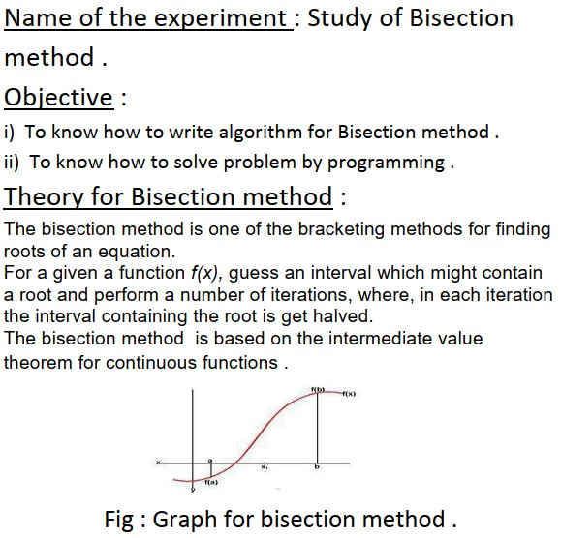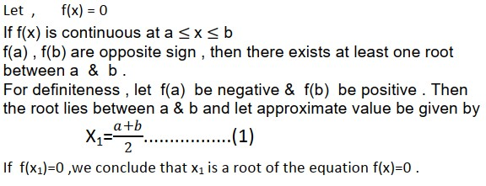

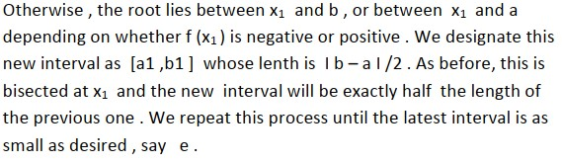

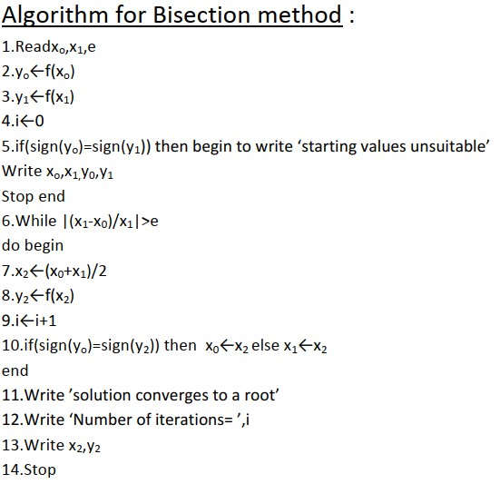

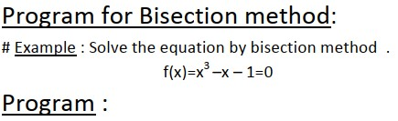

clc; clear all; fx=input('Enter the function ,F(x) = ','s'); f=eval(['@(x)',fx]) ; a=input('Enter a='); b=input('Enter b='); v=b; while(f(b)<0)

b=a; a=v; break; end s=1;

fprintf('N\t \ta\t\t b\t\t x\t\t f(x)\t\t\t Error\n');

for k=1:100;

it(k)=abs(k); x(k)=(a+b)/2;

c=f(x(k)); fprintf('%g %f %f %f %f %f\n',k,a,b,x(k),c,s); if c>0 b=x(k); else a=x(k); end

x(k+1)=(a+b)/2; s=((abs(x(k+1)-x(k)))/abs(x(k+1)))\*100;

if s<=.01 break; end

end

fprintf('\n\n Hence the root is %f ',x(k));

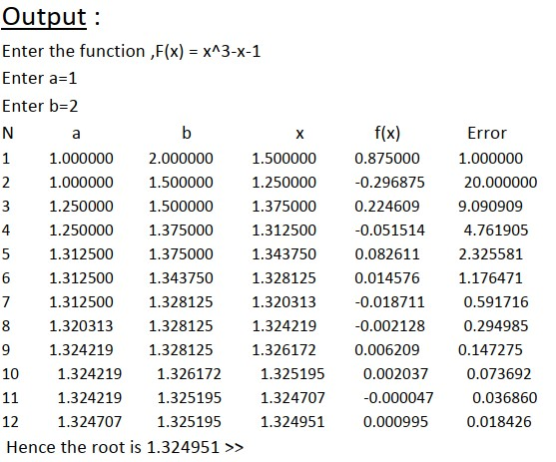

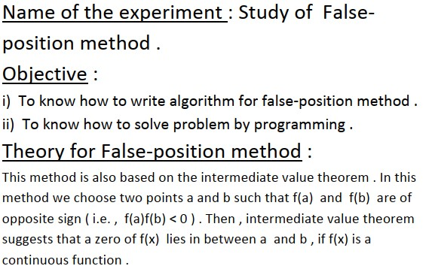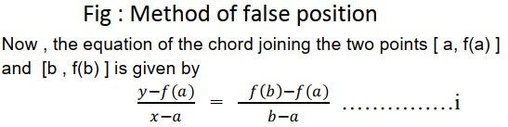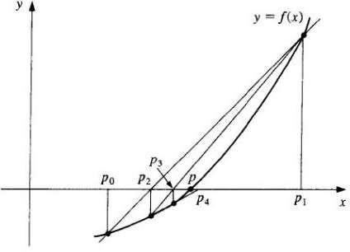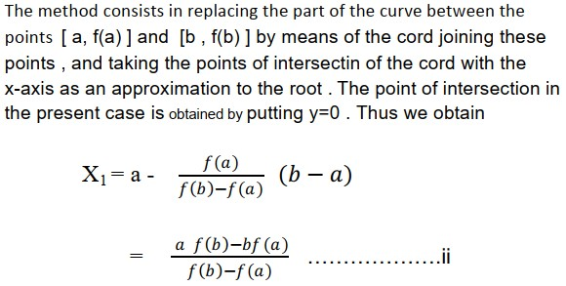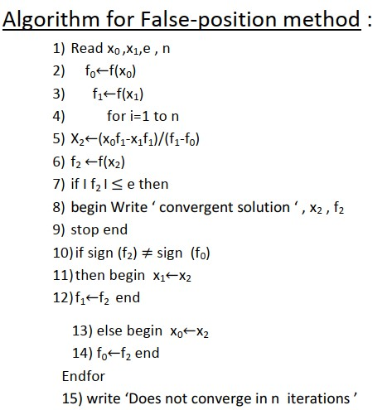

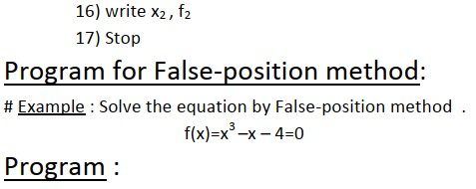

clc; clear all; fx=input('Enter the function ,F(x) = ','s'); f=eval(['@(x)',fx]) ; a=input('Enter a='); b=input('Enter b='); s=1;

fprintf('N\t \ta\t\t b\t\t x\t\t f(x)\t\t\t Error\n');

for k=1:100; x(k)=a-(f(a)\*(b-a))/(f(b)-f(a)); c=f(x(k)); fprintf('%g %f %f %f %f %f\n',k,a,b,x(k),c,s); if c>0 b=x(k); else a=x(k); end x(k+1)=a-(f(a)\*(b-a))/(f(b)-f(a)); s=((abs(x(k+1)-x(k)))/abs(x(k+1)))\*100;

if s<=.01 break; end

end

fprintf('\n\nThe root is =%f',x(k));

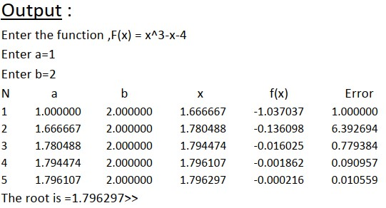

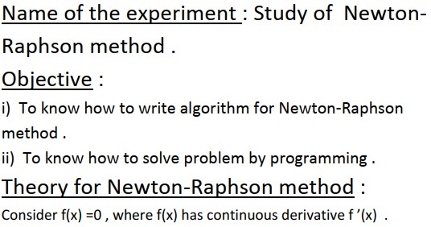

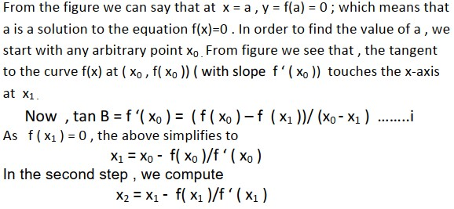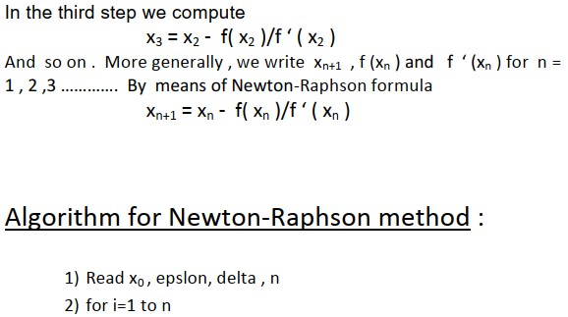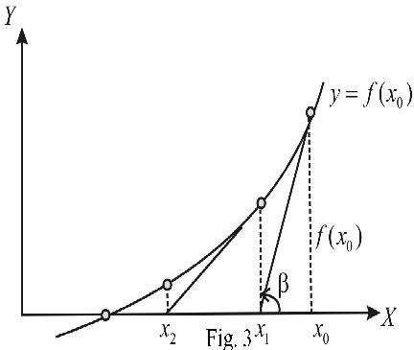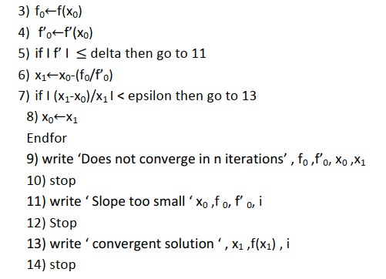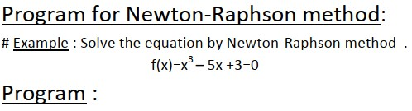

clc; clear all; fx=input('Enter the function ,F(x) = ','s'); f=eval(['@(x)',fx]) ; fx=input('Enter the function ,F"(x) = ','s'); f1=eval(['@(x)',fx]) ; a=input('Enter a = '); s=1;

fprintf('N\t \tX(i)\t\t X\t\t f(x)\t\t Error\n');

for k=1:1:100 x(k)=a-(f(a)/f1(a)); fprintf('%g %f %f %f %f\n',k,a,x(k),f(x(k)),s); a=x(k); x(k+1)=a-(f(a)/f1(a)); s=((abs(x(k+1)-x(k)))/abs(x(k+1)))\*100; if s<=.0001

break; end

end

fprintf('\n\nThe root is =%f',x(k));

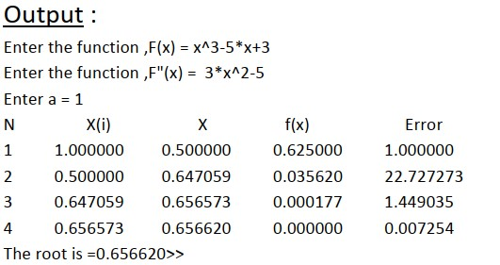

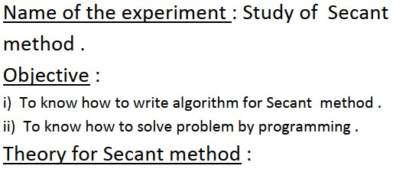

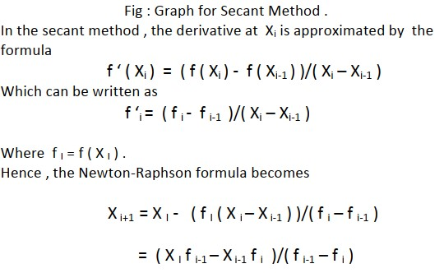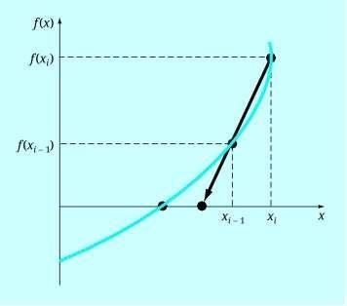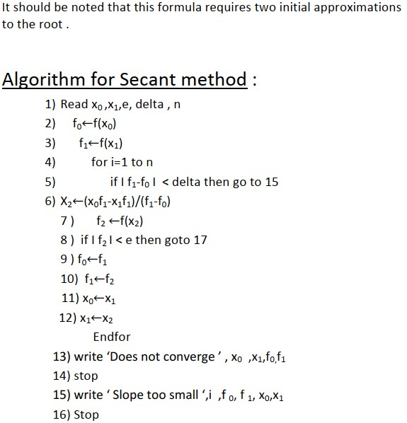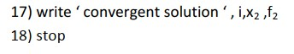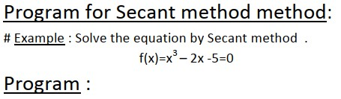

clc; clear all; fx=input('Enter the function ,F(x) = ','s'); f=eval(['@(x)',fx]) ; a=input('Enter a='); b=input('Enter b='); x(1)=a; x(2)=b; s=1; fprintf('N\t\t x(i-1)\t\t x(i)\t\t x(i+1)\t\t f(x)\t\t Error\n'); for k=3:103;

it(k)=abs(k-2); x(k)=x(k-1)-(f(x(k-1))\*(x(k-1)-x(k-2)))/(f(x(k-1))-f(x(k-2))); c=f(x(k)); fprintf('%g %f %f %f %f %f\n\n',it(k),x(k-2),x(k-1),x(k),c,s); s=((abs(x(k)-x(k-1)))/abs(x(k)))\*100; if s<=.001 break; end

end

fprintf('\n\nThe root is =%f',x(k));

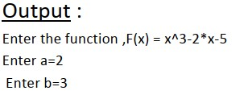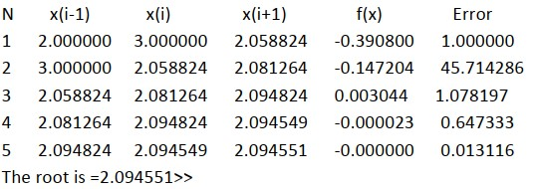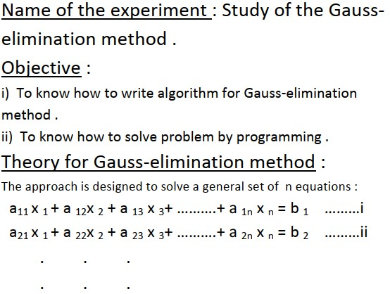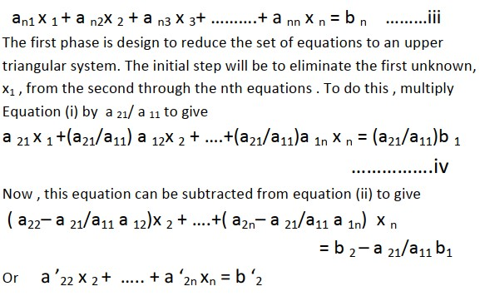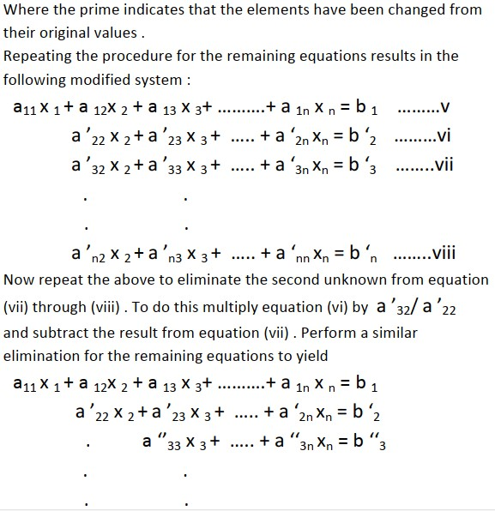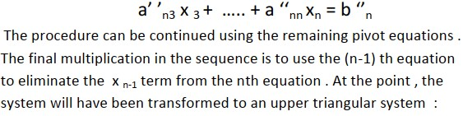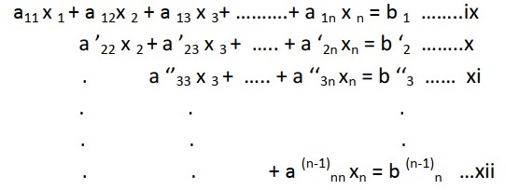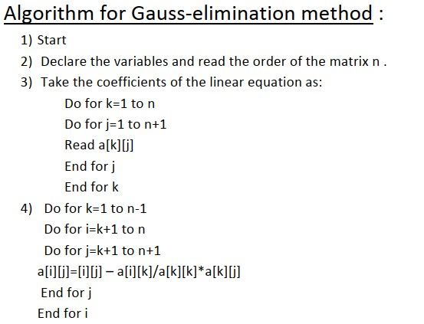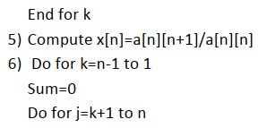

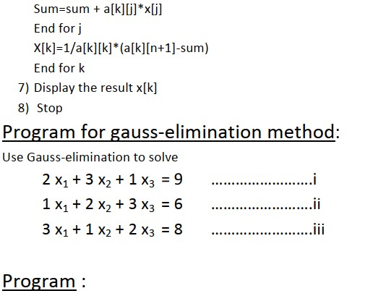

clc; clear all; a=input('Enter matrix A = '); b=input('Enter matrix B = ');

[m,n]=size(a); for k=1:m-1 for i=k+1:m

fact=a(i,k)/a(k,k); for j=1:n a(i,j)=a(i,j)-a(k,j)\*fact; end b(i,1)=b(i,1)-b(k,1)\*fact; end

end x(m)=b(m,1)/a(m,n); for i=m-1:-1:1 sum=0; for j=i+1:n sum=sum+a(i,j)\*x(j); end x(i)=(b(i,1)-sum)/a(i,i);

end

disp('After forward elimination the matrix [A B] :'); disp([a b]); %%Showes a &b in matrix form fprintf('\nThe Required solution : '); for i=1:n fprintf('\nx(%d) = %f',i,x(i));

end

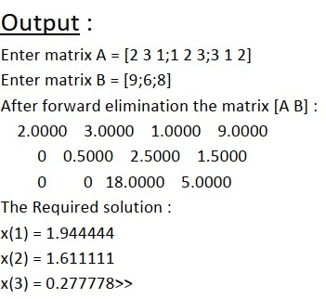

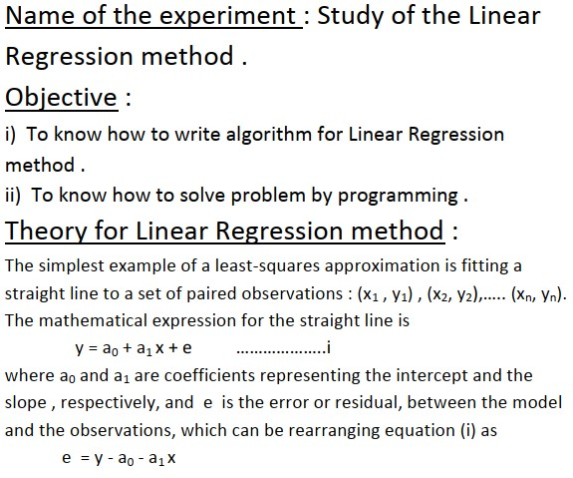

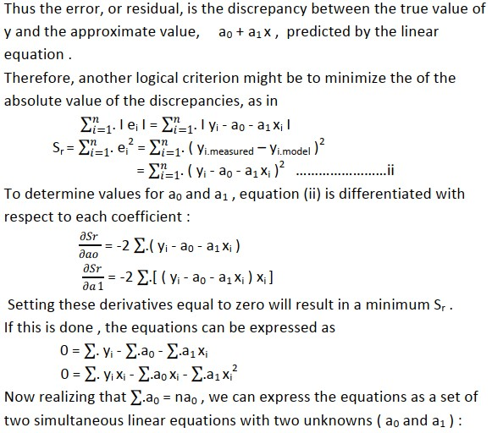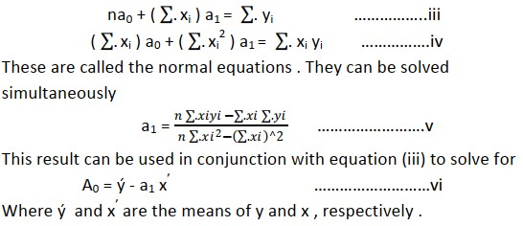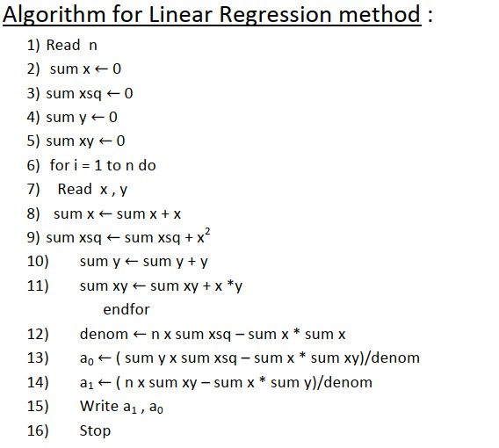

clc clear all n=input('inter the value of n='); x0=0; xsq0=0; y0=0; xy0=0;

for i=1:n x=input('enter the value of x='); y=input('enter the value of y='); x0=x0+x; xsq0=xsq0+(x\*x); y0=y0+y; xy0=xy0+(x\*y); end d=n\*xsq0-x0\*x0; a=(y0\*xsq0-x0\*xy0)/d;

b=(n\*xy0-x0\*y0)/d;

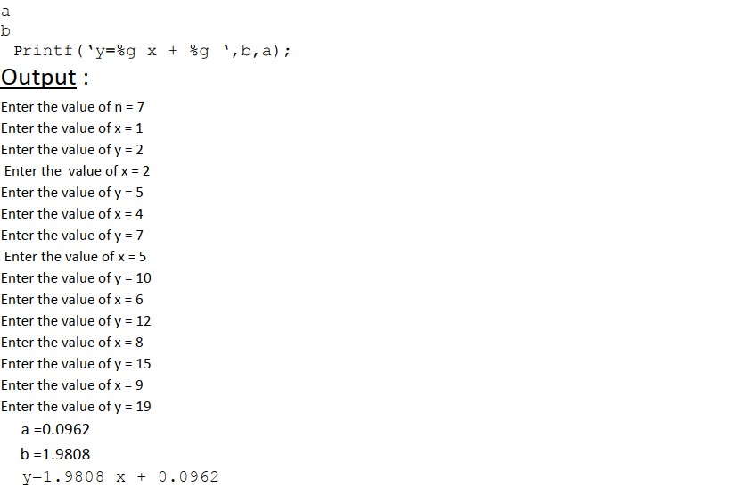

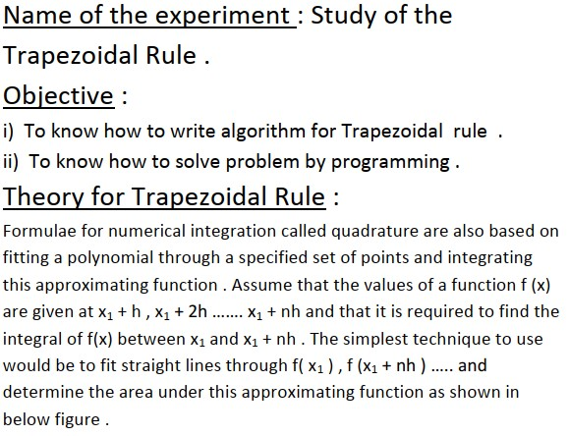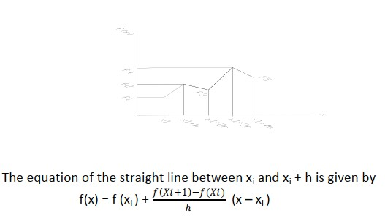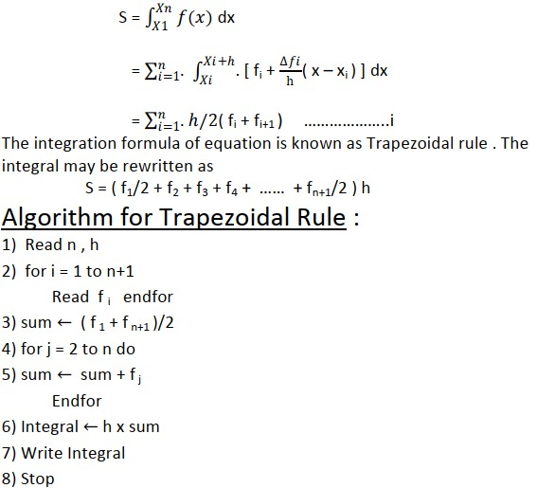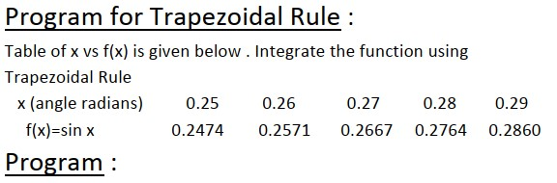

clc clear all

n=input('Enter the value n= '); h=input('Enter the value h= '); for i=1:n+1

f(i)=input('Enter the value f(i)= ');

end sum=(f(1)+f(n+1))/2; for j=2:n sum=sum+f(j); end

Integral=h\*sum;

Integral

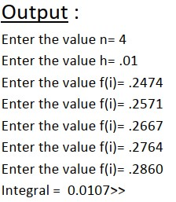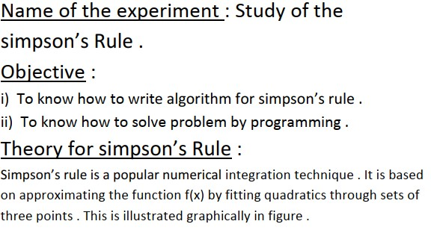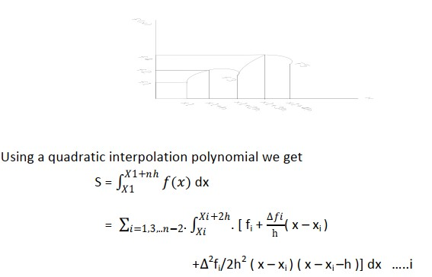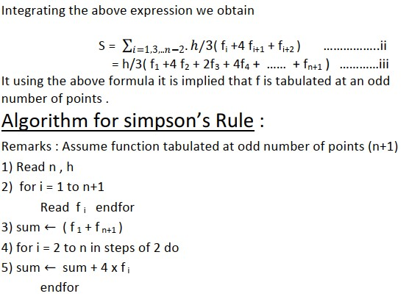

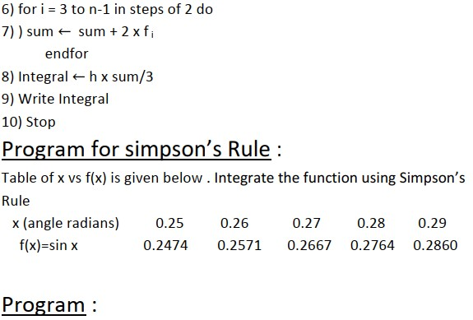

clc clear all n=input('Enter the value of n= '); h=input('Enter the value of h= '); for i=1:n+1

f(i)=input('Enter the value of f(i)= ');

end

sum=(f(1)+f(n+1));

for i=2:n sum=sum+4\*f(i); end for i=3:n-1 sum=sum+2\*f(i) end

Integral=h\*(sum/3);

Integral

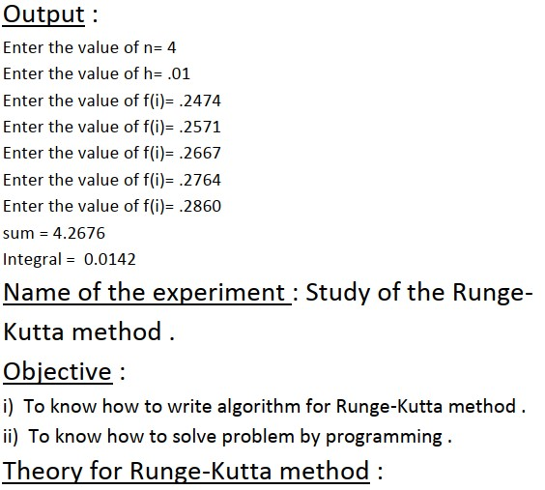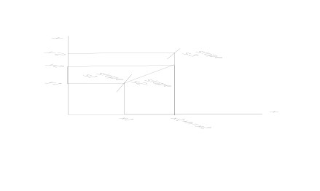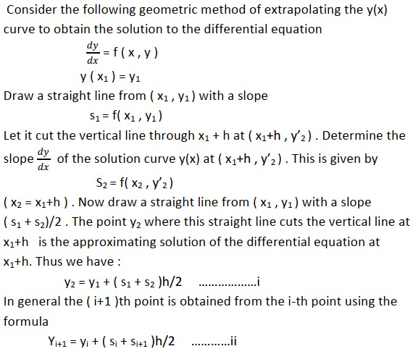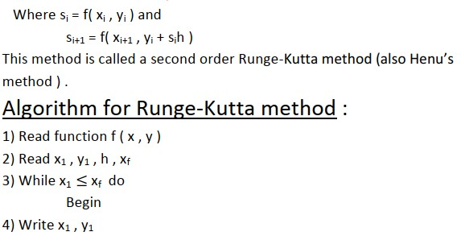

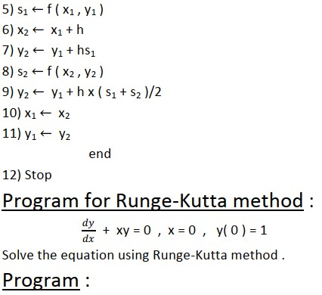

clc clear all fx=input('Enter the function ,dx/dy = ','s'); f=eval(['@(x,y)',fx]) ; x1=input('initial value of x1= '); y1=input('initial value of y1= '); xp=input('input x at which y is required xp= '); h=input('input step size h= '); n=(xp-x1)/h; for i=1:n m1=f(x1,y1); x2=x1+h; y2=y1+h\*m1; m2=f(x2,y2); y2=y1+((h/2)\*(m1+m2));

x1=x2;y1=y2:end

fprintf('At x=%g the value of y(%g)=%f',xp,xp,y2);

